

**EXPRESSION OF INTEREST (EOI)**

**FOR Video Analytics Solution**

Table of Contents

Company Profile 3

Strategic Business Units of Sheba Group at a glance: 3

Manegement Summary 4

Registered Address 5

Contact Person 5

History 5

Organizational Structure 6

Logistics 6

Facilities 6

Skill set 7

WORK CENTRE WITH MODERN FACILITIES 7

EFFICIENT LOGISTIC & EQUIPMENT 7

Transport 8

Training Facility 8

Experience in software development 9

features of Proposed solution: Video analytics system 11

Objective of Proposed Automation System 11

Hardware Dependencies: 14

Sample System Architecture 15

Software Platform and Technology 15

system Avalability and pricing model 16

sheba technologies ltd portfolio 17

## Company Profile

**Sheba Technologies Limited (STL)** is part of the Sheba Group conglomerate which has been in Tech business for almost quarter of a century. We are always keen on listening to our customers and are constantly learning from their experiences while rendering Telecom and IT services. This has made us recognize the importance of evolving into the new ‘normal’ which is ‘Data is everything’. With this aspiration, STL is fully committed to bring world class technologically advanced Business Process Automation by delivering architecturally superior Software solution, Off-the-Shelf customizable Software, Digital Identity platform for Citizens, Smart City initiatives, Artificial Intelligence and Machine Learning to our esteemed clients who are also our long-term strategic partners.

Sheba Group is one of the most trusted names in Corporate Bangladesh with more than two decades of experience in the country’s telecommunication sector. The Group has 200+ full-time executive employees. Sheba Group’s diversified business interest encompasses: (1) Telecommunications, (2) ICT, (3) Education, (4) Construction, (5) Real Estate, (6) Fisheries, (7) Food & Beverage and (8) Capital Markets. The Group enjoys impeccable reputation for ethical business conduct and strives to bring innovation and value through young and entrepreneurial leadership. Sheba Group is also performing CSR activities and takes pride in opening and operating the country’s first palliative care home for cancer affected children.

## Strategic Business Units of Sheba Group at a glance:

1. Sheba ICX Limited
2. Integrated Services Limited (Sheba Phone)
3. Teleport Bangladesh Limited
4. AHC Securities Limited
5. AHC & Co. Limited
6. Sheba Technologies Limited
7. Sheba Digital Limited
8. Toron Ltd.
9. Sheba Land Management Limited
10. Salma Afzal Trust (SAT), an initiative of Sheba Group for CSR activities
11. AHSIC Foundation, an initiative of Sheba Group for CSR activities

## Manegement Summary

**Afzal H. Choudhury** is the Founder & Group Chairman. He started his career at BTTB and later started his own business. He has a B.S. degree in Electrical Engineering and has obtained advanced training on Satellite Telecommunications in 1973 from the USA.

**Asif H. Choudhury** is the Group Managing Director. He has been involved with Sheba Group since 2002. Prior to joining Sheba Group, he worked for Credit Agricolebank in their project finance unit and also worked at CDIC as an analyst. He has an undergraduate degree in Economics and Political Science from Rutgers University and an MBA from McGill University.

**Reaz U. Ahmed** is the Chief Executive Officer, responsible for Group’s Telecom and ICT business development and operations. He has worked for high tech companies for more than 10 years in the heart of Silicon Valley, California. He has a B.S. degree in Electrical Engineering from Rutgers University.

**Farhan Islam** is the Chief Operating Officer of Sheba Technologeis Ltd. He has 16 + Years of IT experience in both United Kingdom & in Bangladesh. He holds a B.Sc Computer Science degree from University of Portsmouth, United Kingdom.

**Mohammed Alauddin** is the Chief Coordinator of the Sheba Group having 35 years of experience in Telecommunications and satellite communication, he has worked in Bangladesh and in the Kingdom of Saudi Arabia. He holds a B.S. degree in Electrical Engineering from BUET and also received training in Telecommunications from UK, Canada, Pakistan and USA. He is a Senior Fellow of the Institution of Engineers Bangladesh (IEB).

**Mohammad Somael Kabir** is the Chief Technology Officer for the Group’s Telecom and ICT Planning, Implementation and Operations. He has 12 years of experience in Telecom and ICT infrastructure planning, capacity analysis, business plan development and system implementation.

## Registered Address

House no. 55, 5th Floor, Road no. 4/A, Dhanmondi R/A, Dhaka-1209

Corporate Office: 8th Floor, Khawja Tower, 95, Mohakhali C/A

## Contact Person

Farhan Isalm : Cheif Operating Officer (COO) – Sheba Technologies Ltd.

Mobile number : +880-1711547804

# History

**2012**

**2015**

# Organizational Structure

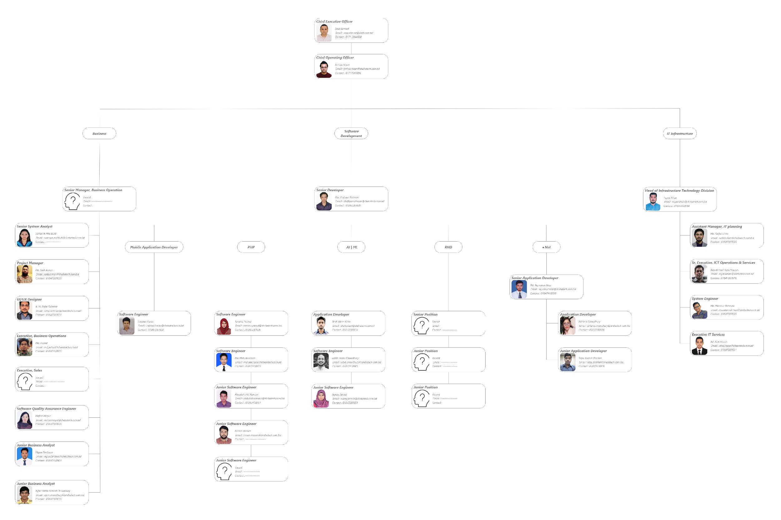

# Logistics

## Facilities

**Well-organized corporate office –** Sheba Technologies Limited is maintaining a well-organized registered office at Khawaja Tower (8th Floor), 95 Mohakhali C/A, Dhaka, with all modern and state of the art office facilities and Data Center It's total personnel force amounts to more than 40.

Ample floor space –

|  |  |  |
| --- | --- | --- |
| **Sl. No.** | **Description** | **Sq. ft.** |
| 1 | Conference Room | 250 |
| 2 | Data Center | 1200 |
| 3 | Office and others | 4,350 |
| **Total Floor Space** | | **5,800** |

## Skill set

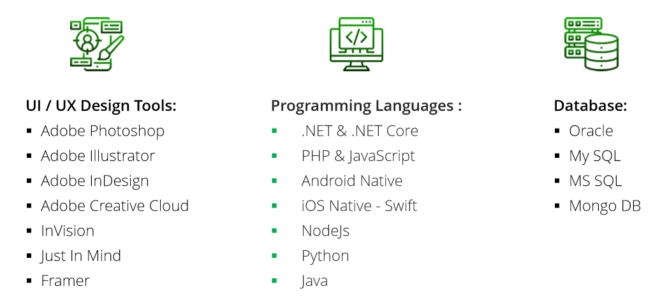

### WORK CENTRE WITH MODERN FACILITIES

The work centre of Sheba Technologies Limited offers excellent environment with all modern facilities of hardware, software and networking. The total floor space is approximately 5000 sft and is equipped with a wide array of hardware including sophisticated and powerful PCs, Laptops, Laser Printers, Scanners and color printers. STL is fully equipped to provide all necessary logistic support for various Software development, training and consultancy project activities. It has all sorts of modern and up-to date computers and peripheral equipment.

STL Ltd. has a well organized registered Head office at House no. 55 (3rd floor), Road no. 4/A, Dhanmondi, Dhaka with all modern office facilities.

### EFFICIENT LOGISTIC & EQUIPMENT

STL uses modern IT equipment, servers and peripherals to accomplish its business activities which are designed to fulfill the needs of Internal and External Clients efficiently. The hardware consists of:

|  |  |  |
| --- | --- | --- |
| SL | Items | Quantity |
| 1 | Desktop PC | 26 |
| 2 | Laptop (Core i3, i5, i7) | 22 |
| 3 | Brother Laserjet Network Printer (Color) | 1 |
| 4 | HP Laserjet Network Printer | 2 |
| 5 | Scanner | 2 |
| 6 | Multi Media Projector | 2 |
| 7 | IP Telephone/ SIP Phone (AASTRA/ HUAWEI) | 15 |

### Transport

|  |  |  |
| --- | --- | --- |
| SL | Items | Quantity |
| 1 | Pool Vehicle | 4 |

### Training Facility

STL possesses a state of the art Training Centre with all the modern facilities. One of the sister concern of STL, AHC & Co. has State of the ART training rooms with the following facilities:

* Fully furnished air-conditioned training room that can accommodate up to 40 participants
* A large conference room that can accommodate up to 20 participants
* A fully fledged centre having state of the art computer and wifi internet facilities
* Overhead Multimedia projector and suitable audiovisual equipment
* Facilitator/Moderator/Rapporteur/Receptionist/ Attendants services
* Computerized Study Materials

# Experience in software development

**Project: Grameenphone, Bio-Metric Verification Solution**

**Description:** Flexible, Low Cost, Scalable and Open Architecture solution. Seamless connectivity with EC’s NID DB and faster identity verification process. Currently supports 4 fingerprints for each hand, can be extended to all fingerprints for both hands.

**Project: Grameenphone, Mobile Device Management (MDM) Solution**

**Description:** Mobile Device Management (MDM) Solution, provides full control over the user device with the following functionalities.

* Enroll/Install, Collect;
* Collect/Reporting;
* Monitor/Dashboard;
* App Management;
* Control;
* Security;

**Project: Smart Service For Uttara Motors Limited**

**Description:** An Android/iOS Mobile application with full featured back office Service Center Management along with Content Management System (CMS) for the Mobile App. The application enables, Customers, request service appointments, maintain vehicle historical service history, SOS Calls, Manage Vehicle Paper Works and many more.

**Project: BYLC Graduates Portal (ConnectEd)**

**Description:** ConnectEd, a job portal developed for BYLC, is a blend of a Social Media Platform with a Job Portal. Here, all students of BYLC can interact with one another, send new friend requests to a long lost friend, share their memories and current achievements. The platform also provides the opportunity to scan through all registered employers, follow up or apply for new suitable vacant positions.

**Project: Enterprise Resource Locator (ERL)**

**Description:** Enterprise Resource Locator is a Mobile Resource Management Solution for Enterprises to efficiently & effectively manage field resources.

**Project: EKYC, United Commercial Bank (POC)**

**Description:** E-KYC application needs to be developed for Android, Windows & Web Client platform; the application will be used to verify customers National Identification (NID) Verification from Election Commission (EC) along with MSISDN Verification NID from CBVMP (BRC) Central Biometric Verification Management Platform (CBVMP) before customer account opening process.

**Project: Digital LAB Monitoring and Management Solution (POC)**

**Description:** Central Dashboard, Multi-level User dashboards, Monitoring and Managing the lab reservations and class schedules, Monitoring Live PC status (Windows/Linux) by deploying agents, Supervision of school management for effective usage. Alert/notification, extensive reporting and messaging, android app for management’s overall status view.

**Project: Point of Sale Solution for The Coffee Bean & Tea Leaf**

**Description:** The point of sale software, every Retailers & Restaurant Managers, would love to use. Simple and Beautiful, The solution is compatible for both Cloud & Locally Hosted Network Infrastructure. In depth Back Office Management features with some exciting unique functionalities, allows the Solution to Stand Out among many other renowned brands, currently in the market.

**Project: Guardian Life Insurance (GLIL) – EKYC**

**Description:** Customer Onboarding Solution as per BFIU guideline.

**Project: IDLC Finance - EKYC**

**Description:** Customer Onboarding Solution as per BFIU guideline.

**Project: United Finance Limited - EKYC**

**Description:** Customer Onboarding Solution as per BFIU guideline.

**Project: MetLife Insurance - EKYC**

**Description:** Customer Onboarding Solution as per BFIU guideline.

**Project: Lankan Insurnace - EKYC**

**Description:** Customer Onboarding Solution as per BFIU guideline.

**Project: SME Dashboard – Loan Managment Platform**

**Description:** Loan Management Platform developed for BRAC bank to monitor loan performance of their SME Clients.

**Project: Task Management Platform, Brac (NGO)**

**Description:** Task management is more than a to-do list. It means tracking tasks from beginning to end, delegating subtasks to teammates, and setting deadlines to make sure projects get done on time. Task management software empowers teams to work more productively and efficiently.

**Project: SDP Career Hub, Brac (NGO)**

**Description:** Our cloud based learning management solution is designed to help you attract retain and develop key talent by introducig effictive, engaging and relevant training to motivate your employees and develop their skills whilst improving the productivity of your workforce.

**Project: AI ERP, Brac (NGO)**

**Description:** The solution includes a mobile application and a web application to cover the whole AI business management ecosystem. Both of the applicaion will cover from sales operation, bull rearing production & inventory tracking to finance and human resource management. Overall, this solution will help taking data driven decision and improve the productivity, reduce human error and enhance enterprise perfromance. As a whole this project will signficantly improve the success of AI enterprise business.

**Project: Service Desk Management, Brac (NGO)**

**Description:** BRAC Technology Division is reorganizing and introducing new services in response to the after-effects of the pandemic. As a result, they require platforms to make their services accessible to other BRAC programmes and external parties. BRAC Technology wants to develop a service desk web platform along with a website that promotes their services. Moreover, the Project Management Unit (PMU) Dashboard requires enhancements that facilitates dynamic reporting that allows generating relevant reports to various key donors and stakeholders.

**Project: UPG Learning Management System, Brac (NGO)**

**Description: Another Learning Managment System for the Ultra Poor Graduate Program -** Our cloud based learning management solution is designed to help you attract retain and develop key talent by introducig effictive, engaging and relevant training to motivate your employees and develop their skills whilst improving the productivity of your workforce

## features of Proposed solution: Video analytics system

* Face Detection and Recognition.
* Voice Recognition.
* Restricted Zone Monitoring.
* Intruder Detection.
* Crime Detection.
* Person / Object Tracking.
* Speech to Text.
* People Counting.
* Number Plate Detection and Tracking

## Objective of Proposed Automation System

1. Face Detection and Recognition:
   * Recognition in real-time with any camera(ipcam, webcam)
   * Employee management system.
   * Work time analytics.
   * Spoof Detection.
   * Mask Detection.

2. Voice Recognition:

* + Extract voices from noise.
  + Recognize voice.

3. Restricted Zone Monitoring:

* + Detect if anyone/any object enters the restricted zone.
  + Recognize the person/object who enters the restricted zone.
  + Track his/her/object’s movements.
  + Generate alert.
  + 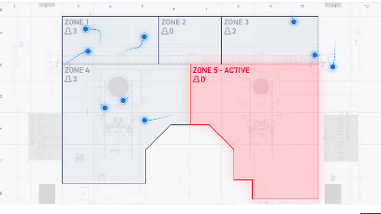Send the identity to the concerned authority.

4. Intruder Detection:

* + Unusual human activity detection.
  + Tracking.
  + The person he/she meets.
  + How long he was present.

5. Crime Detection:

* + Violence Detection.
  + Alert concerned authority.

6. Person Tracking:

* + Track-specific person/objects.
  + 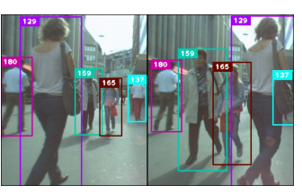Places person/object visits with geo-location(considering a large area).

7. Speech to Text:

* + Transform voice into text.

8. People/Object Count:

* + Count people/object enters in a defined time slot.
  + Track the number of people entering and exiting in a defined zone.



9. Number Plate Detection and Tracking:

* + Detect car number plates.
  + Extract car owner information from database.
  + Tracking the car and keeping its whereabouts.
  + Entry time and exit time analysis.
  + Frequency of presence in weeks/ months/ years.

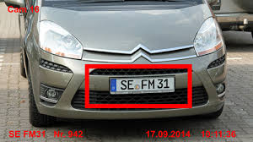

# Hardware Dependencies:

1. Our solution works with any kind of mobile camera, IP camera, CCTV, Webcam.
2. Our solution requires a GPU server to perform properly. The specific GPU server can be defined once the requirement/task is clear.

# 

# 

# 

# 

# 

# Sample System Architecture

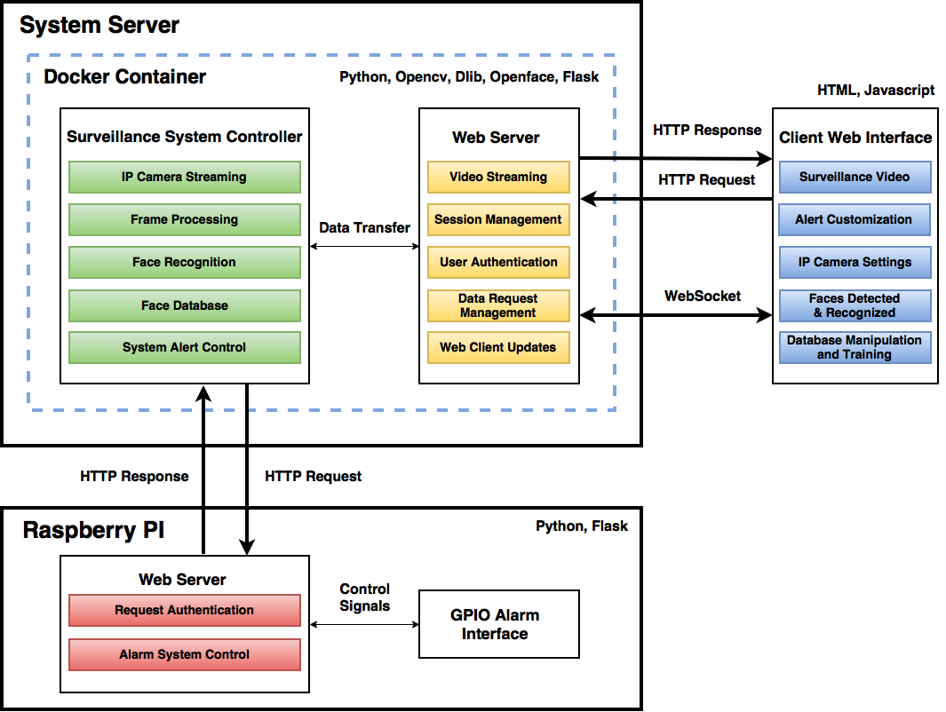

## Software Platform and Technology

* Camera
  + Mobile Camera
  + IP Camera
  + CCTV
  + Webcam
* AI Engine
  + Pytorch/Tensorflow
  + FastAPI
  + Dlib
  + OpenCV
* AI Engine Host
  + Google Cloud Platform
  + Amazon Web Service
  + Local Server
* Browser Web Pages
  + HTML/Angular JS Responsive Web Application
* Front-end Support/Analytics Dashboard:
  + PC Web browsers: IE, Safari, Chrome, Firefox
  + Android and iOS mobile Platforms
* Web Server / Application Server
  + Python/Apache
* Database
  + MySQL
  + MongoDB
  + Redis
* Single Sign-on supported
* Scalable Load-Balancer
  + HA-Proxy/ Hardware Based
* Application and Database-tier Operating System
  + Linux

# system Avalability and pricing model

* Available in Both On Premisis and On Cloud Model.
* Available in Both Perpitual and Subscription Model.

# sheba technologies ltd portfolio

